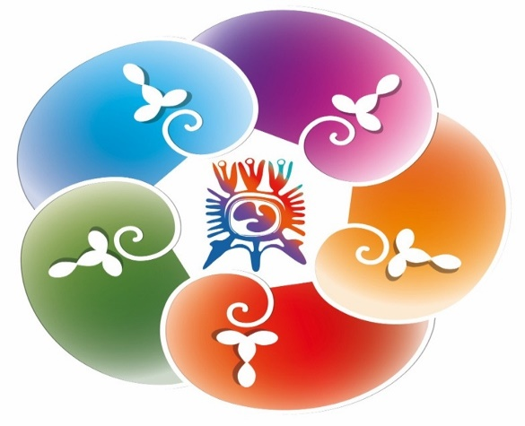

Online Taster Session to experience
*Capacitar Wellness Practices
During each experiential taster session we will explore the body-based wellness practices of Capacitar, working with the healing flow of the body using simple Tai Chi movement, breath-work visualisation, self-acupressure and energy work. Each of the practices enable relaxation, calm and trauma healing.
The practices are wonderful for self-care and for sharing with others.
Led by CapacitarUK Trainers:
Paul Golightly (England)
Nancy Adams (Scotland)
Friday February 11th & Saturday February 19th
1000 - 1300 on Zoom
(each taster session will be the same, so you only need to book for one of them)

To express interest, email capacitarscotland@gmail.com for the Zoom link
*Capacitar is a Spanish word which means to empower and enable.
Capacitar International works in 45 countries worldwide.
For more information: www.capacitar.org or www.capacitaruk.org

